IoT-Based Firefighter Dashboard

*Vatsal Makani*

*Department of Computer Engineering*

*STD ID: 013731614*

*Email-ID:* [*vatsalkirit.makani@sjsu.edu*](mailto:vatsalkirit.makani@sjsu.edu)

*Vaishnavi Ramesh*

*Department of Computer Engineering*

*STD ID: 013726609*

*Email-ID:* [*vaishnavi.ramesh@sjsu.edu*](mailto:vaishnavi.ramesh@sjsu.edu)

*Abstract*— The proposed venture (Firefighter dashboard) will be utilized for the fireman's well-being safety measures. In the present situation, firemen are not inserted with any sensor gadget, henceforth it gets hard to monitor all the firemen by the foreman. This task means to get all the telemetry information of the fireman colleagues and send it to the group captain by showing it in the front end HTML 5-CSS JavaScript-based dashboard/site. The mechanical obstacles that will be related to this task are interfacing equipment sheets by St Microelectronics containing locally available sensors with Google Cloud and Firebase Back end. After the fruitful finish of this task, the firefighting foreman will screen the telemetry information and as needs are given guidelines to its colleagues forestalling any life loss/injury. The essential territory of use will be for the Firefighting division, in any case, with some drug, and including different sensors, this task application will be reached out to military activities or any games undertakings like outdoors. In the present situation, firemen are not inserted with any sensor gadget, consequently, it gets hard to monitor all the firemen by the team leader.

*Index Terms*—Dashboard, firefighter, fire safety, front end, html5, CSS, JavaScript, Node JS, embedded systems, STM32, Socket.io, back end.

# INTRODUCTION

T

HE firefighters play a very important role when it comes to safety and rescuing people out of danger. Sometimes, these firefighters risk their own lives to save the lives of the common man. These firefighters must face very critical, life-threatening, and dangerous environments and are exposed to many health critical elements like fire, smoke, dust, noises, and explosion. The KMPSS organization also carried out a survey where they found that almost 2 out of 10 firefighters lost their lives performing their duties annually [1]. The statistics show that more than 80% of firefighters diagnosed with vision problems and 99% of firefighters lose their hearing ability [2][4]. Moreover, the trouble of perceiving their present area, the loss of correspondence framework, and the disengagement from collaborators and group commanders happen habitually than anticipated occasions. Along with these problems altogether, these firefighters also face a cognitive disability which leaves a permanent mark in their personal lives.

The report of the US FEMA in 2016 says the all-out number of fireman fatalities in the line of obligation or delayed consequences from mishaps of flames was 90 in the year 2015 [3]. The 60 firefighters passed away of worry from putting out fires obligation and heart assault brought about by over-weakness. Additionally, complete 21 firemen passed away with their boots placed in the foot; 16 passed on from breakdown happened unexpectedly during the mission extinguishing the fire and protecting survivors and 5 were died because of the seclusion on the scene of flames [3]. Some external factors need to be considered when we investigate firefighter’s safety concerns. firemen's devices including fire suits, oxygen tanks, head protectors, and boots are ordinarily overwhelming and regularly gives a dull impression of contact, smell, and sound. Likewise, elements such as smoke, tidies are typically malicious to firemen's well-being, which ultimately leads to serious wounds or life losses [5][6][7].

Additionally, a few conditions are even dangerous infra-less; infra including force and correspondence was obliterated, along these lines the utilization of lighting, ventilation, and correspondence media, (for example, GPS, LTE, Wi-Fi) is unthinkable, and any signs or orders from outside are not reachable. That is, firemen are "secluded" in a fire scene. There have been accounted for that numerous firemen passed on in these infra-less situations [8]-[12]. The reasons were that firemen couldn't perceive the right area and bearings to an exit [8] [9], couldn't appropriately distinguish crisis (e.g., absence of pneumatic force, irregular pulse, fiery surges) [10] [11], or potentially couldn't speak with collaborators and even lost some of them [9] [12]; particularly in the episode revealed in [12], missing of a veteran fireman was perceived after over seven hours after the fact. These are an outline of issues that firemen must face in their regular daily existences.

There is a need to research and develop the technologies and methodologies to ease the job of the firefighters and aiding operations and guaranteeing firefighter’s safety who always face the high-risk environment such as collapse, flashover, blackout, etc. There have been many technologies and research that are carried out to understand the dynamics of the situation of the firefighter.

This paper proposes a technological solution in the form of a dashboard, or a web application named Firefighter dashboard will be utilized for the fireman's wellbeing and precautionary measures against risky dangers. In the present situation, firemen are not implanted with any sensor gadget, and often, firemen must reestablish manual strategies for raising the alert when they are presented to perilous natural circumstances. The current creation identifies with sensor information observing which gives a robotized caution framework to checking numerous parameters during firefighting exercises and giving fitting directions or signs to a fireman to advise him regarding a risky circumstance. This paper means to get all the telemetry information of the fireman colleagues and send it to the group captain. The arrangement being created for the firemen and their colleagues, remembering their necessities the significant market portion of the item means to be Fire Department, yet it very well may be stretched out to different networks, military, and game bold gatherings, by including or deducting some sensor controllers according to their prerequisites.

The remainder of this paper is organized as follows. Section II proposes the related work regarding the project topic and how our solution can be used to improve the efficiency of the existing proposed solution. Section III proposes a system architecture of the proposed. In section IV, we show the implementation and development of the proposed services and hardware. Section V offers concluding remarks and issues for further studies. Finally, section VI provides the acknowledgment for our work with references in section VII.

# Related Work

The safety and concerns about the health of the firefighters have grown to an utmost important issue. Many authors have worked to provide efficient and justifiable solutions while some authors contribute a part of a major solution. Kojakian and Viken (2019) provided a solution to deploying indoor localization for tracking the firefighters. The paper proposes three methods to compute the distance between the damaged node which simulates the actual firefighter and the other active anchor nodes. The main objective of that solution was to provide a proof-of-concept of the technologies that can be used; however, it came with limitations of the range of operation [13].

Sang Gi Hong, Kyo-Hoon Son, Hyesun Lee, Myungnam Bae, Kang Bok Lee (2018) explained a solution of implementing the augmented services to the firefighters. Their paper explains the hardware architecture, the software framework and localization features to track the firefighters. They have also implemented an emergency SOS signal mechanism to notify the firefighters [14]. However, the accuracy of the positioning mechanism needs to be improved. Another efficient solution was proposed by Hyesun Lee, Myungnam Bae, Dong Beom Shin, Sangyeoun Lee, Seung-Il Myeong, Sang Gi Hong, Hoesung Yang, Jinchul Choi, Kyo-Hoon Son, Kang Bok Lee, Hyo-Chan Bang (2017). Their paper proposes a new system that shall be used to protect and save the lives of the firefighter in the “infraless” fire environments. The solution features pedestrian dead reckoning, map matching, safety monitoring, data sharing, AI, and navigation feature [15]. They have validated the results by collecting real user data from the National Fire Academy.

Megha Kanwar and Agilandeeswari L (2018) have proposed a firefighting robot that is based on IoT, sensor monitoring, and dashboard display. The robot sends the fire alert to the cloud which is monitored using the dashboard as an Android Application. Along with the alert, it also sends the value of carbon dioxide to determine the type of fire and trained to extinguish it. Be that as it may, discovering fire type so it very well may be smothered with the assistance of proper methods. Existing models utilizing Bluetooth modules have a less range [16]. Situations like fire scenes need robots that can be controlled from anyplace on the planet. Constant checking is required for a superior view.

“Another type of Fire Extinguisher System is produced by Poonam Sonsale et al. The paper proposes a versatile combination calculation for flame location. It utilizes a smoke sensor, fire sensor, temperature sensor for flame identification. It contains keen multisensory based security framework that contains a putting out fire’s framework in everyday life. The security framework can identify unusual and perilous circumstances and tell. Clever structures are required to be more secure helpful and effective living conditions for society. The motivation behind Intelligent Fire Extinguisher System is to douse the fire in a specific measure of time. The framework recognizes the area of the fire and smothers it by utilizing sprinklers. As being Intelligent System, it removes the power of zone where the fire has been gotten and begins the sprinklers just of that area.[17]

Remote Controlled Fire Fighting Robot developed by Phyo Wai Aung describes the functions of remote-control firefighting robots. It contains two main parts that are the transmitter and receiver in which two sets of RF modules are used. One RF module is used to transmit the data to the motor driver and another RF module is used to know the condition on fire. Microcontroller PIC16F887 is used to operate the whole system of the firefighting robot. The motors are driven by the L298 and ULN2003 drivers in this system. The operator controls the robot by using a wireless camera mounted on the robot. If the temperature of fire sight is above 40 degrees Celsius, the alarm will be ringing so that operator can control the firefighting robot and avoid the damage of heat. [18]”

Our solution shall have the following features that can easily be used to tackle the limitations mentioned from the previous work and improve the efficiency

1. A portable embedded system development kit with various onboard and external sensors which will

provide the firefighter team leader/ marshal with cognitive information in real-time including their location in the building, environmental hazard factors such as temperature, pressure, air quality, humidity, etc.

1. A conveyed working together programming stage supporting to gather, spare, procedure, and offer data gained structure every convenient gadget.
2. An interactive web application that shall be controlled and monitored by the firefighter marshal and give the information of its firefighter subordinates in the form of a google map interface and a feature to get the data analytics of hazard exposure which will help them strategize the future firefighting activities.

# System Architecture

The proposed system architecture to provide intelligent services to firefighters is shown in Figure 1. The entire system is composed of embedded system development kit by STMicroelectronics, Google cloud interface, Firebase backend, and a dashboard/web application that is developed using node Js, Express JS, Socket.io and React framework.

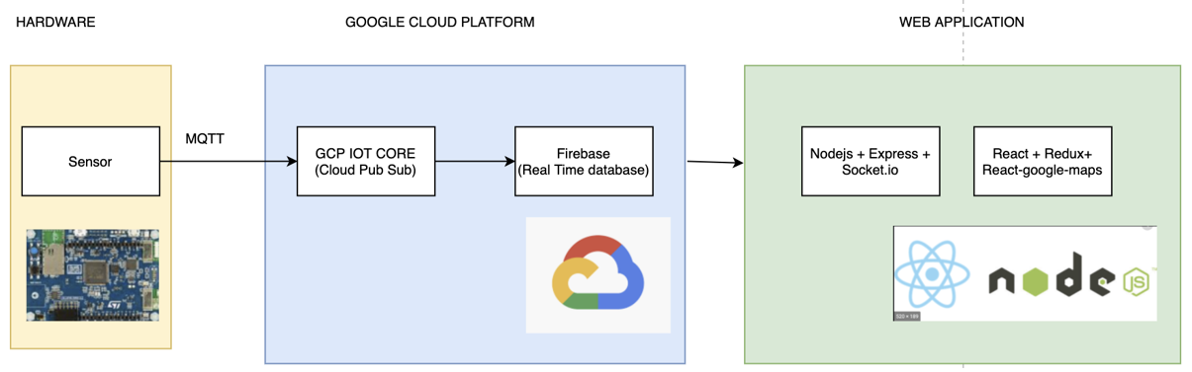

Figure System Architecture

1. *STMicroelectronics Hardware Development kit with external sensors*

The hardware selected for this project is STMicroelectronics STM32 IoT Discovery Kit (B-L475E-IOTA). “The B-L475E-IOT01A Discovery kit for IoT node allows users to develop applications with a direct connection to cloud servers.” [19]. The development board is controlled by the ARM Cortex M4 series microcontroller which comes in the STM32L4 series.

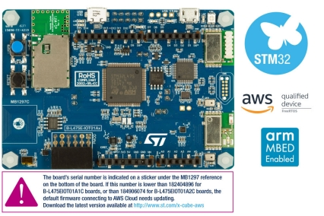

Figure B-L475E-IOTA development board

This 64-bit controller has 1Mbyte of Flash, 128Kbyte RAM, and provides integrated support of all the telemetry sensors such as HTS221 temperature, pressure, humidity, etc. along with Wifi module to send the data over the cloud. We shall also be connecting a GPS module and CO Sensor externally.

The GPS module used in this project is Mikroe based GNSS 4-Click module.

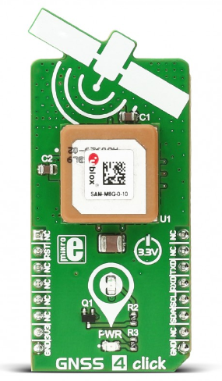

Figure GPS module by Mikroe

GNSS 4 click carries the SAM-M8Q patch antenna module from u-blox. The click is designed to run on a 3.3V power supply. It communicates with the target microcontroller over I2C or UART interface.

The CO-sensor used in this project is by Spec Sensor. This sensor is used to provide the relative humidity and air quality value in PPB. The gas concentration of CO Sensor ranges from 800PPB to 2000PPB for normal environmental conditions, since the natural concentration of carbon monoxide in air is around 0.5 to 1 ppm, and that amount is not harmful to humans.

The CO sensor is always producing a signal if the instrument is turned on. In the presence of CO, the signal goes up. In fresh air, you still get a signal, but the value is lower. When you fresh air zeroes the instrument you are telling the instrument to use the signal from the sensor at that moment as the point of comparison.

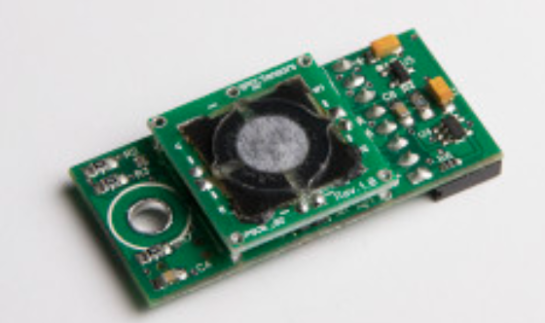

Figure CO-Sensor

1. *Google Cloud*

Google Cloud Platform (GCP is a foundation of distributed computing administrations that sudden spikes in demand for a similar framework that Google utilizes inside for its end-client items. Close by a lot of the executives devices, it gives a progression of measured cloud administrations including registering, information stockpiling, information investigation, and AI.



Figure GCP platform

We shall be making use of IoT Core and Pub/Sub API to use the IoT management services, publishing the sensor values, and subscribing to a topic.

1. *Firebase server*

Firebase is a Backend-as-a-Service used for next-generation app-development platform on Google Cloud Platform.



Figure Firebase

It interacts with the Google cloud platform to store the real-time data and store it in a Realtime database, and used for storing files, hosting the websites. It offers great scalability for big data applications.

1. *Web application Technology*

Backend Services are created in Nodejs. Unit test cases were written using the Jest framework. Load Testing was performed using JMeter. A JavaScript module of Pub-Sub is used to subscribe to the endpoint which listens to the various services.

The major endpoints created were Login, Signup, list all pinpoints, get details of single points, show analytics on historical data. Since the database acts as the endpoint, all details get filled in it.

We used a fire store-schema node JavaScript module to talk to the database. The data in the fire store is stored as documents. A group of documents makes a collection.

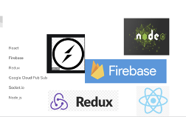

Figure 7 Web Technologies

# Implementation and Development

1. *STM32 embedded board interfacing with external sensors (hardware)*

The STM32 IoT Discovery Kit consists of 4 UART channels which can be used to interface the external sensors. Figure 7 shows the actual setup of sensors interfaced with the STM32 discovery kit.

“We connected the GPS module to a GPS antenna with RX and TX pins connected to UART4 pins (PA0 to RX and PA1 to TX). The module is communicating at the baud rate of 9600 bps. After setting the baud rate, we get GPRMC data over the output. From the format, we can see that latitude and longitude is the only information that needs to be parsed. The location value in this format is a combination of actual latitude and longitude as well as the time. So, we implemented a parsing logic that scans the values as per the format, stores in variables, and converts to actual latitude and longitude”.

CO Sensor is provided by a Spec sensor that works on UART communication. We have various modes that can be configured to get the CO sensor data like Gas Concentration (PPB), humidity, and temperature.

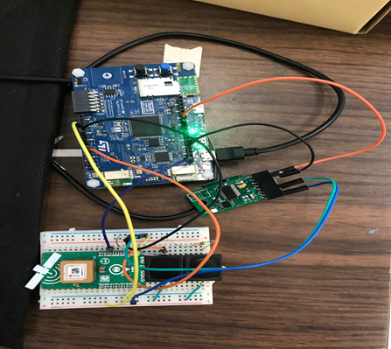

Figure Sensors interfaced with STM32 IoT Discovery Kit

The pin connections are illustrated in the below table.

|  |  |
| --- | --- |
| **B-L475E-IOT01A pins** | **Sensor Pins** |
| PA_0 (D1) | ‘RXD’ pin for GPS Sensor |
| PA_1 (D0) | ‘TXD’ pin for GPS Sensor |
| PA_3 (D4) | ‘TX’ pin for CO Sensor |
| PA_2 (D10) | ‘RX’ pin for CO Sensor |
| 3.3V | ‘3.3V’ pin of GPS module  Pin 8 of CO Sensor |
| GND | ‘GND’ pin of GPS Module  Pin 6 of CO Sensor |

1. *Publishing the sensor data to the Google Cloud Platform*

To publish the data to google cloud, we must make a free google cloud account, register, and enable the APIs. The steps are mentioned in section 5.2 of the GCP User Manual [20]. The Application flow for entire code shall be as follows:

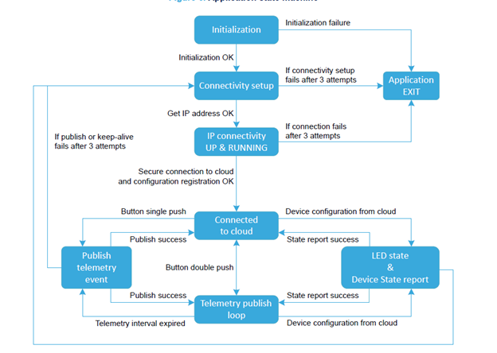

Figure GCP pub/sub-flow diagram

I had used a Google cloud package (X-CUBE-GCP) [21] for deploying the IoT functionality for STM32 IoT Discovery Kit.

Since GPS and CO sensors require UART communication, we added 2 instances of UART in the package and retrieved data at the interrupt. Once the GCP function starts, the UART2 and UART4 interrupts are triggered and UART_RXCallback() was executed, where it started storing the sensor data as a string.

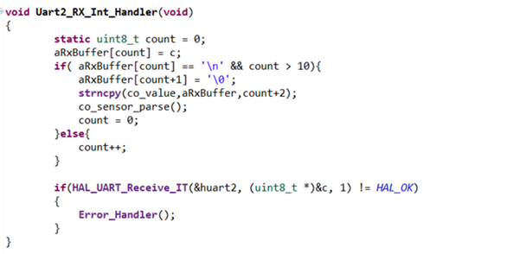

Figure UART RX Handler

In addition to sending the GPS latitude and longitude and CO sensor’s gas concentration and relative humidity, I sent the temperature, pressure, accelerometer, and gyroscope data to the cloud. The GCP package has an API built in to get the readings from the onboard temperature sensor, accelerometer, and gyroscope. Once the data was present in the variable, the next step was to send data over the google cloud. We stored the data format into a character buffer using snprintf() and strcat() and converted it to the JSON format.

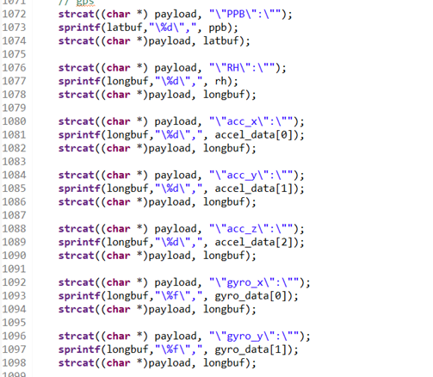

Figure JSON Format data

Once the code is dumped in a microcontroller, we set the terminal settings as mentioned in User Manual [20] and follow the steps. Once the configuration is completed, press the blue button twice to send data over the google cloud.

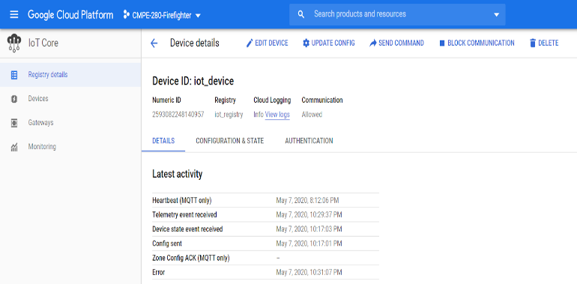

Figure GCP receiving the data

It will subscribe to a pub/subtopic and publish the data over that topic. After the successful sending of data, the google cloud indicates the date and time of data published.

1. *Back end*

There are 6 major services:

·   Login

·   Sign Up

·   Show all geographical pins

·   Display details on a single pin

·   Display analytics on historical data.

The user’s collection had details about all the users – these details included first name, last name, age, location, temperature. The sensor collection includes details like humidity, temperature, pressure, etc. It also shows the user, whose sensor data is being displayed. Based on this, we were able to query the database and display relevant data.

The tests are written using the jest framework. We run the command npm test to see a comprehensive list :

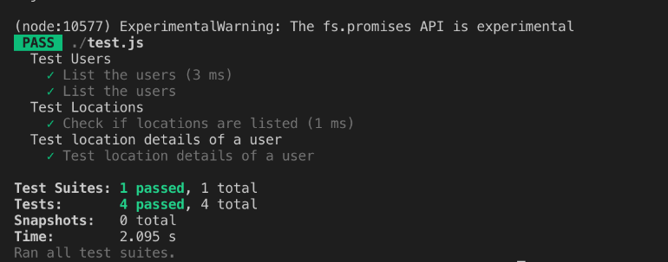

Figure 13 JMeter framework Unit testing

We performed JMeter Testing on the API and these are some of the results

For 100 concurrent users:

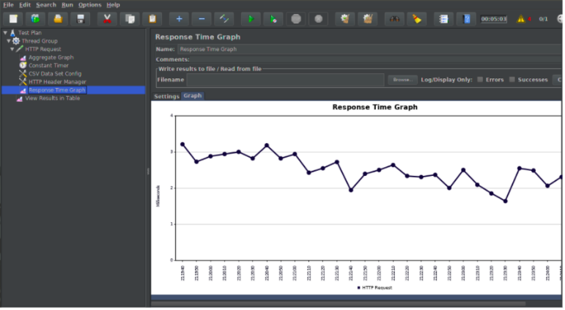

Figure 14 100 users’ data analytics

For 500 concurrent users

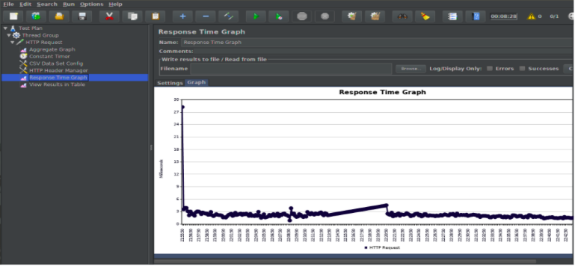

Figure 15 500 user’s data analytics

1. *Front end website*

The front end application was created using React, Redux, and react-google-maps module. Redux was used to maintain the states easily.

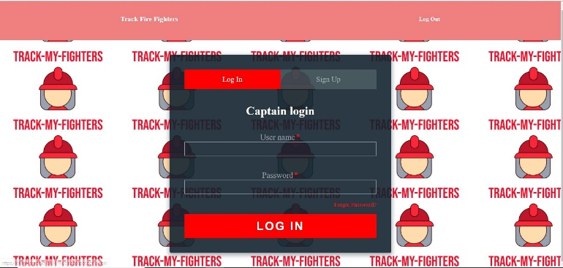

Figure Login Page of the Web Application

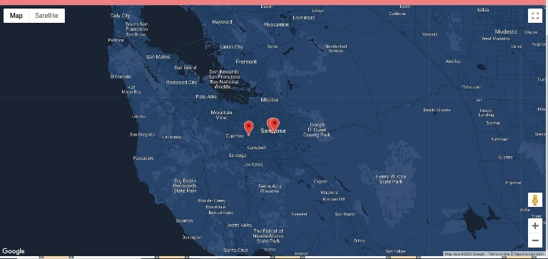

Figure Web Application Main Screen

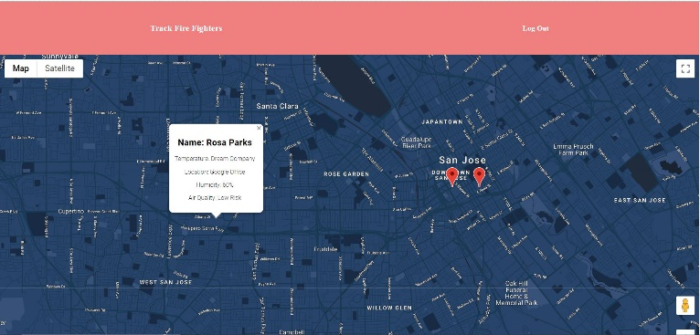

Figure Firefighter tracking with sensor information

1. *Hosting*

The frontend and backend are hosted in the Google Cloud system deployed in Firebase backend.

This is a snapshot of our usage of the google cloud deployed in Firebase

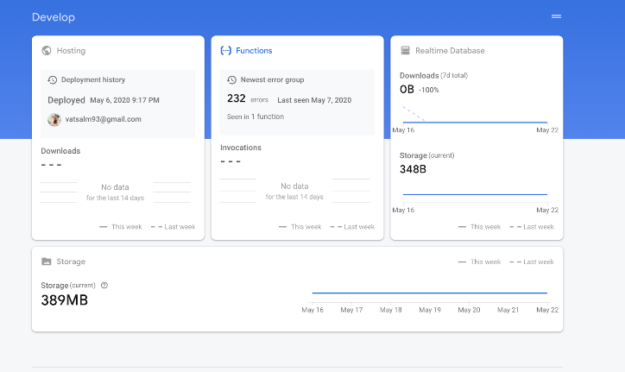

After hosting, we can see our usage through charts

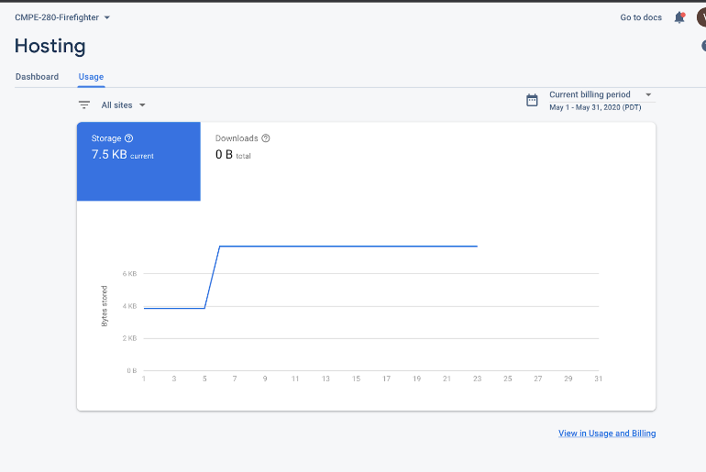

# Conclusion

“In the profession of firefighting, firefighters generally experience difficulties in adjusting to the working field due to the degradation of sensing ability of vision and hearing. They are also confronted with the absence of co-working firefighters in the scene due to the communication isolation [15]. These situations increase the psychological anxiety of firefighters. Besides the insufficient information on environmental hazard and own bio-signal status may cause an accident taking the life of a firefighter during the mission”.

The paper provided elaboration for each of these sub-systems along with their system architecture, how they interface with the cloud, store the sensor data, and parse it to display it in the dashboard and website. We also pointed out the disadvantages such as unable to lock GPS in remote locations, miscalibrated sensor values, and tried to address them using various solutions.

Thus, this paper provides another solution to ensure the safety of the firefighters during their operation. After detailed research, implementation, and evaluation of results, we can say that the proposed solution has its pros and cons, and their application depends on a scenario. As this product is initially targeted for local firefighter department, so after completion of the product, this prototype will be experimented to monitor the product’s efficiency, we can expand the domain to medical applications where blood pressure sensor, a sensor to measure glucose, etc. can be integrated and monitored by the doctors.

# Acknowledgment

We would sincerely like to thank our course professor Mr. Chandrasekar Vuppalapati from San Jose State University for his guidance and support throughout the project and guiding the completion of this research paper.

# References

1. D. Kim, “Seven firefighters died on duty every year…the percentage is 5 times more than Japan,” MBC News, Jul. 22, 2014. URL = http://imnews.imbc.com/replay/2014/nw1800/article/3 497190_18437.html (in Korean) [accessed: Nov. 22, 2016].
2. C. M. Countryman, “The concept of fire environment.” Fire Management Today, p. 49, 2004.
3. US Fire Administration (2016, October). Firefighter Fatalities in the United States in 2015.
4. S. Hong, “Study on the strategic development of damage for casualties mitigation policies: Empirical analysis of critical factors about casualties due to fire,” Master Thesis, Kyonggi University, 2011. (in Korean).
5. P. W. Brandt-Rauf, L. F., Fallon, T. Tarantini, C. Idema, and L. Andrews “Health hazards of firefighters: exposure assessment,” British journal of industrial medicine, Vol. 45, No. 9, pp. 606-612, 1988.
6. L. Rosenstock, and J. Olsen, “Firefighting and death from cardiovascular causes,” New England Journal of Medicine, Vol. 356, No. 12, pp. 1261-1263, 2007.
7. K. S. Kim, “Health hazards in firefighters,” Hanyang Medical Reviews, Vol. 30, No. 4, pp. 296-304, 2010.
8. J. Park, “Firefighters died on duty at Incheon,” The Kyunghyang Shinmun, Nov. 3, 2012. (in Korean). URL=http://news.khan.co.kr/kh_news/khan_art_view.h HTML?artid=201211031131221&code=940100/ [accessed: Nov. 22, 2016].
9. E. Noh, “A Veteran firefighter died on duty,” The kyunghang Shinmun, Nov. 05, 2012. (in Korean). URL=http://noheunggeun.khan.kr/119/ [accessed: Nov. 22, 2016].
10. M. Kang, “Fire occurred in a Pyeongtaek warehouse..two firefighters died on the job,” MBC News, Dec. 3, 2011. (in Korean). URL=http://imnews.imbc.com/replay/2011/nw1200/art icle/2976617_18764.html/ [accessed: Nov. 22, 2016].
11. Y. Jeong, “A firefighter died on duty again,” Korea Joongang Daily, Mar. 8, 2001 (in Korean). URL=http://news.joins.com/article/4047089/ [accessed: Nov. 22, 2016].
12. K. Kim, “The disappearance of a firefighter in fire environment at a stationery warehouse in Ilsan,” The Hankyoreh, Dec. 31, 2012. (in Korean). URL= http://www.hani.co.kr/arti/society/area/567663.html [accessed: Nov. 22, 2016].
13. Kojakian, Viken, et al. "Firefighter indoor localization (POUCET)." 2019 IEEE Radio and Antenna Days of the Indian Ocean (RADIO). IEEE, 2019.
14. Lee, Hyesun, et al. "ATHENA: Distributed IoT Systems Providing Salient Features for Safety of Firefighters in Infra-Less Fire Environments." 2017 International Conference on Platform Technology and Service (PlatCon). IEEE, 2017.
15. Hong, Sang Gi, et al. "Augmented IoT service architecture assisting safe firefighting operation." 2018 Global Internet of Things Summit (GIoTS). IEEE, 2018.
16. Kanwar, Megha, and L. Agilandeeswari. "IoT Based Fire Fighting Robot." 2018 7th International Conference on Reliability, Infocom Technologies, and Optimization (Trends and Future Directions) (ICRITO). IEEE, 2018.
17. Poonam Sonsale, RutikaGawas, Siddhi Pise, Anuj Kaldate, “Intelligent Fire Extinguisher System”, IOSR Journal of Computer Engineering (IOSR-JCE) e-ISSN: 2278-0661, pISSN: 2278-8727Volume 16, Issue 1, Ver. VIII (Feb. 2014), PP 59-61.
18. Phyo Wai Aung, Wut Yi Win, “Remote Controlled Fire Fighting Robot”, International Journal of Scientific Engineering and Technology Research Volume.03, IssueNo.24, September-2015
19. “B-L475E-IOTA”by STMicroelectronics. Available: <https://www.st.com/en/evaluation-tools/b-l475e-iot01a.html> [Accessed: May 22, 2020]
20. “Google Cloud Package” User Manual. Available: <https://www.st.com/content/ccc/resource/technical/document/user_manual/group1/e9/8a/9b/73/5c/ff/4d/10/DM00522079/files/DM00522079.pdf/jcr:content/translations/en.DM00522079.pdf> [Accessed: May 22, 2020]
21. “X-CUBE-GCP” by STMicroelectronics. Available: <https://www.st.com/en/embedded-software/x-cube-gcp.html> [Accessed: May 22, 2020]